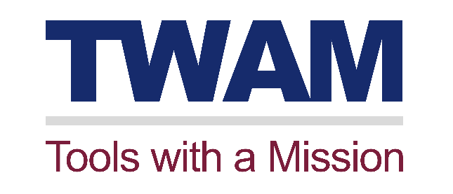

We’re keeping things nicely ticking over

It’s tough times for all of us right now and TWAM’s no exception. Government advice on essential travel, social distancing and self-isolation for people over 70 has hit us very hard and left us with no option but to shut down our UK operation in March. As a result, we took the tough but necessary decision to place half of our six staff into the Government furlough scheme.

However, this does not mean we’re doing nothing, we are actually rather busy running the office, acknowledging and banking donations, and paying the bills. We’re also still taking requests for tool donations, ready for the bounce back.

We are also working hard to keep supporters and volunteers updated with all our usual mailings going out. We have also doubled the number of e-news we send out to supporters and volunteers, so they are kept informed of our progress in these uncertain times. We’re still writing our magazine and the next copy will be off to the printers soon. We also have a major 3-month campaign in Saga Magazine launching in June. This is really important as we need to ensure income continues to come in and TWAM maintains its planned growth.

We are also supporting our overseas partners and volunteer teams, as they continue to distribute our tools and work through their own challenges of lockdown and various state of emergencies. We are planning our next Team Conference for our Partner and volunteer team in Zambia, hopefully this October.

The work goes on to process tool applications, prepare containers to go out once we are back to work and oversee the delivery of several containers currently at sea or going through customs.

Finally, we are bringing forward major plans while we have some slack. Firstly, will be a major step forward in the tool application process, with the design and build of our very first smartphone app. Secondly, we are re-evaluating all the resources we offer to applicants of our tools to help them set up and run long term sustainable projects. This includes an updated ‘How to set up a Self-Help Cooperative Guide’ and a ‘How to set up a Community savings Scheme Guide’ plus new development posters to be distributed by our in-country teams.

We’re planning the big Bounce Back
We’re also really looking forward to getting things back to normal with containers out the door again and on their way to Africa. We hope to get the first container off to Uganda the first week we’re back.

We’re planning a major volunteer recruitment campaign for our Midlands Centre, and to recruit many more volunteers in the North of England. This will include advertising, social media campaigns and special volunteer days.

We’re looking at a big appeal to launch the ‘Bounce Back’ with great ways for our loyal supporters to help us, from sponsoring the van back on the road for a day, to paying to send the container for a set number of miles of its journey at sea. It will be a very exciting appeal.

We’re also preparing the big tool donation bounce back with advertising and promotions to make sure, when we do start getting the containers out, we’ve plenty more tools coming in.

We recognise that bouncing back will not be easy, so we’ve got lots more work to do preparing to implement the plan. Oh, and did we mention Christmas and the Big Give Appeal?

So we still need your support, more than ever, as we’re still going forward, while preparing for one of the biggest challenges in our history; the bounce back.

All this ongoing work ensures the most vulnerable in communities across Sub-Saharan Africa get the livelihood creating tools they need when life returns to normal and food still needs putting on the table.

Thank you.

Mike Griffin
CEO, Tools with a Mission

